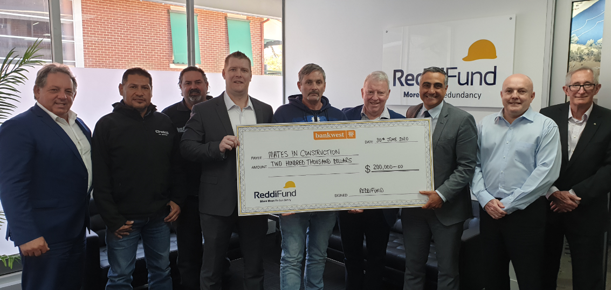
MONEY FOR MATES
ReddiFund gives much needed boost to suicide prevention
Prominent construction industry redundancy fund, ReddiFund have once again demonstrated their value and their commitment to the construction workers in Western Australia by handing over a cheque for $200,000 to MATES in Construction WA.
MATES provide construction workers with suicide awareness training to help reduce the rate of suicide within the construction industry.
Their face to face training provides workers with the skills and awareness that can help them pick up warning signs in themselves and in work colleagues and offer an understanding ear and professional help.
ReddiFund CEO Kieron Gubbins said he was proud to be able to deliver for the workers of our industry.
“We’re proud to provide services that give workers in our industry some financial security as financial insecurity is a major contributing factor to thoughts of suicide.”
“But we’re also proud to be able to help directly through our ongoing funding of this important at suicide prevention program.”
“WA construction workers suffer some of the highest rates of suicide of any group in the country. MATES is a critical part of addressing this problem.”
MATES has been operating in WA for 8 years and in that time ReddiFund has provided over $2.7m in critical funding.
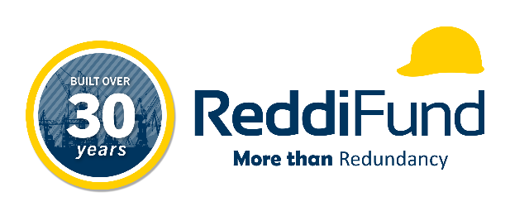
If you’re struggling, then please seek help. Call the MATES National Helpline on 1300 642 111.

